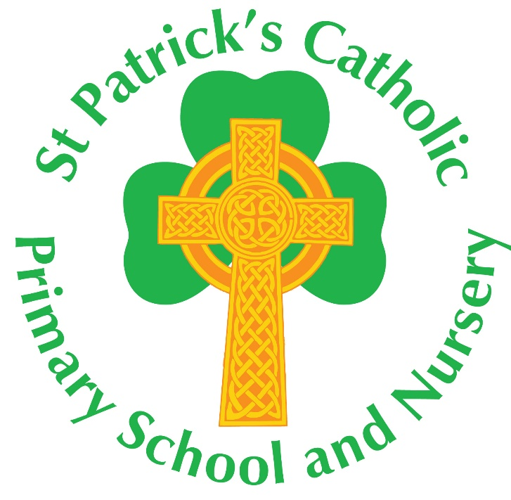

Prayer and Liturgy Policy

Responsibility for policy update lies with the R.E. Subject Leader | Dates Adopted
 | 02.07.24

‘Christ be with me and Christ be within me.’

Prayer and liturgy Policy

At St Patrick’s Catholic Primary School, we believe that prayer brings everyone together into the presence of God. It is a vital part of our life and draws us together as a Christian community. Therefore, we aim to implement our mission statement through our thoughts, our words and our actions.

Aims
- to help the children in our care to develop a deepening relationship with God.
- to give them opportunities to explore their feelings and attitudes towards different life experiences through prayer, reflection and meditation.
- to come together daily as a caring community to pray, reflect, celebrate, praise, worship, thank and recognise God in our lives.

Our times of prayer take place throughout the school daily. This is further enhanced by the liturgies celebrated at key times throughout the year. This can be in the whole school, key stage or classroom context.
- Monday – Monday mornings begin with our Gospel Assembly. This is led by the Head teacher and is based on the resources of the Ten:Ten Collective Worship programme.
- Friday - our Celebration Assembly is led by the Head teacher or Assistant Head teacher. At which the children’s work and behaviour is rewarded and celebrated through a range of certificates. As well as those entered into the Gold Book for demonstrating our School Values, ‘pupils of the week,’ spelling champions, Mathletics champions and attendance champions are all congratulated. As are any in-school sporting achievements and any certificates the children have brought from home for achievements outside of school – football, swimming, gymnastics, Beavers, Brownies, Cubs etc Birthdays that have happened in that week are also celebrated as a school community.
- Daily in-class Collective Worship is led by class teachers/students on a Tuesday, Wednesday and Thursday. These sessions are guided by the Ten:Ten Collective Worship programme and all link to our Monday Gospel Assembly.
- Worship through hymns is led by the Head teacher at our weekly ‘Rejoice and Sing’ assembly.
- End of term whole-school assemblies are led by the Head teacher. At which the children’s work, behaviour and attendance is rewarded and celebrated through certificates, medals, trophies, prizes for maths and reading undertaken at home. As well as those entered into the Gold Book for demonstrating our School Values, ‘pupils of the week,’ ‘pupils of the term,’ and any certificates the children have brought from home for sporting achievements, Beavers, Brownies, Cubs etc Birthdays that have happened in that week are also celebrated as a school community.
- Our new school year starts with Mass in our school hall.
- During the Advent Term, the Faith Friends attend the Diocesan Schools’ Mass, lead a Harvest Assembly, lead the praying of the Rosary in October and an Advent service at the start of Advent. Reception Class lead a Nativity and the whole school take part in a traditional Carol service that is narrated and acted out by Years 1 and 2.
- At the end of the Lent term Year 3 and 4 lead our Easter Performance. Also in the Lent Term, we have an Ash Wednesday service, led by the Faith Friends, and on the Feast of St Patrick (17th March) we come together for Mass. We also have a whole school assembly celebrating and remembering the life of St Patrick which parents and parishioners are invited to.
- During the Pentecost Term the EYFS take part in a May Crowning of Mary and all children and staff are invited to pray the Rosary on a weekly basis led by the Faith Friends.
- All Faith Friends meetings, staff meetings and INSET days begin in prayer.
- Our school year ends with our Leaver’s Mass.

We acknowledge the legal requirement that there must be a daily act of worship for all pupils. We understand that simply holding an assembly that includes a prayer, said either by the teacher or everyone present, does not fulfil this requirement. We also acknowledge that prayer, liturgy and assemblies are distinct activities and may sometimes form part of the same gathering, but there will always be an opportunity for personal reflection and spiritual development.

Parents have a right to withdraw their child from ‘Collective Worship’. However, given the importance of prayer and liturgy in a Catholic school, parents and prospective parents will be made aware of the fact that it can never be confined to ‘timetabled slots’ and may take place in a variety of contexts other that those which are specifically structured.

The resources used in St Patrick’s Catholic Primary School are inspired by the Prayer and Liturgy Directory: To Love You More Dearly.

